**Australian Islamic College 2021**

**ATAR Chemistry Units 3 and 4**

**Task 1 (Weighting: 5%)**

**Acids and Bases, and Redox Test**

Test Time: 50 minutes

Please do not turn this page until instructed to do so.

|  |  |
| --- | --- |
| **First Name** | **Surname** |
|  |  |

|  |
| --- |
| **Teacher** |
|  |

|  |  |
| --- | --- |
| **Mark / 43** | **Percentage** |
|  |  |

Equipment allowed: Pens, pencils, erasers, whiteout, rulers and non-programmable calculators permitted by the Schools Curriculum and Standards Authority.

**Special conditions**:

2 marks will be deducted for failing to write your full name on this test paper.

**Teacher help:** Your teacher can only help you during your test in one situation. If you believe there is a mistake in a question show your teacher and your teacher will tell you if there is a mistake in the question and if appropriate, how to fix that mistake.

**Spelling of Science words** must be correct. Unless otherwise indicated, science words with more than one letter wrong (wrong letter and/or wrong place) will be marked wrong. The spelling of IUPAC names must be exactly correct.

Unless otherwise stated, **equations** must be written balanced and with correct state symbols or they will be marked wrong.

For questions worth more than one mark involving calculations, your working out must be shown. Calculations that cannot be easily understood by the marker or that do not follow a logical sequence from top of the page to the bottom of the page will lose marks.

The final answer of calculations worth more than one mark must be stated to the appropriate number of significant figures.

Follow-on marks will not be paid.

Questions must be answered in this booklet.

**Part 1: Multiple Choice Section 12 Marks**

Circle the one most correct answer.

1. Which one of the following pairs of statements is correct for both electrolysis cells and galvanic cells?

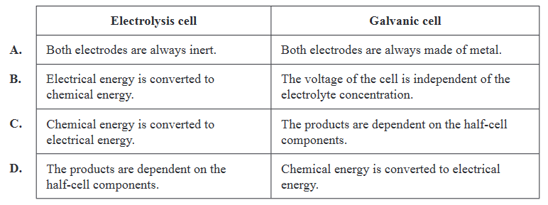

1. This question is about these species.
   * 1. IrO4+
     2. C7H7+
     3. SO42-
     4. HPO(OH)2

Which species contain the atoms with the highest and lowest oxidation numbers respectively?

* 1. i and iv.
  2. i and ii
  3. iii and iv
  4. iii and ii

1. The conjugate acid of substance X is H4SiO4 What is the conjugate base of substance X?
   1. H3SiO4-
   2. H2SiO42-
   3. HSiO43-
   4. H2SiO32-
2. At the start of the day, a student set up a galvanic cell using two electrodes: nickel, Ni, and metal X. This set-up is shown in the diagram below.

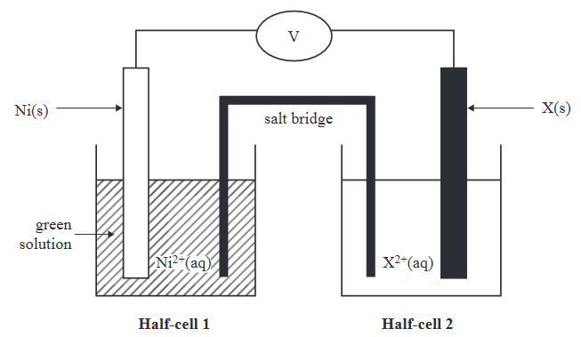

Consider the following alternative metals that could be used to replace metal X:

1. zinc, Zn 2. lead, Pb 3. cadmium, Cd 4. copper, Cu

At the end of the day, the student checked the colour of the solution in Half-cell 1 and observed that the solution was a darker green colour.

Which of the alternative metals could cause the colour of Half-cell 1 to become a darker green?

* 1. Metals 1 and 3
  2. Metals 2 and 4
  3. Metals 1, 2 and 3
  4. Metals 3 and 4

1. What is the concentration of hydroxide ions (OH–) at pH 12.3.
   1. 2.00 x 10-1 mol L-1
   2. 2.00 x 10-2 mol L-1
   3. 2.00 x 10-3 mol L-1
   4. 2.00 x 10-4 mol L-1
2. Consider the following statements about galvanic cells and fuel cells.

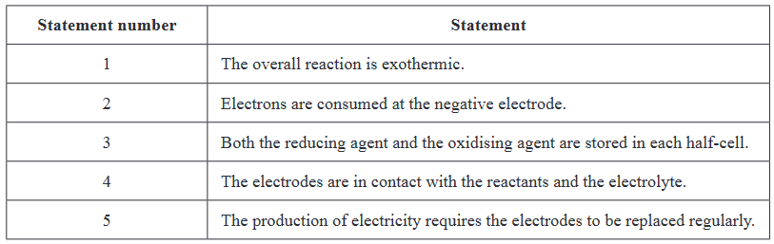

Which one of the following sets of statements is correct for both galvanic cells and fuel cells?

* 1. Statement numbers 2 and 3.
  2. Statement numbers 1 and 4.
  3. Statement numbers 2, 4 and 5.
  4. Statement numbers 1, 3 and 5.

1. Pyrophosphoric acid is a strong tetraprotic acid with the formula H4P2O7. Being a tetraprotic acid, the ionisation of pyrophosphoric acid can be written as a series of four Brønsted-Lowry reactions where the value of Ka is smaller for each successive ionisation reaction. What are the products of the final ionisation reaction?
   1. P2O74- and H2O
   2. P2O74- and H3O+
   3. HP2O74- and OH-
   4. HP2O74- and H3O+
2. Which one of the following galvanic cells will produce the largest cell voltage under standard laboratory conditions (SLC)?

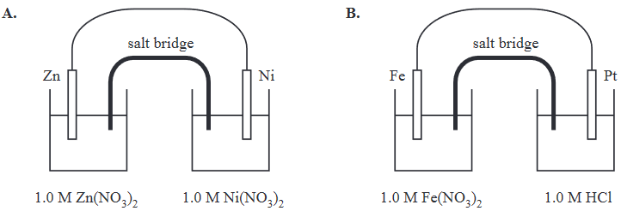

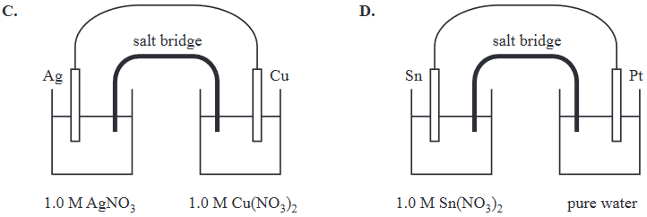

1. Hydrogen peroxide solutions are commercially available and have a range of uses. The active ingredient, hydrogen peroxide, H2O2, undergoes decomposition in the presence of a suitable catalyst according to this reaction:

2H2O2(l) 🡪 2H2O(l) + O2(g)

In this reaction, oxygen:

* 1. Only undergoes oxidation.
  2. Only undergoes reduction.
  3. Undergoes both oxidation and reduction.
  4. Undergoes neither oxidation nor reduction.

1. The experiment shown below was set up to investigate the relative strengths of two unknown acids. The power supply was connected to two graphite rods.

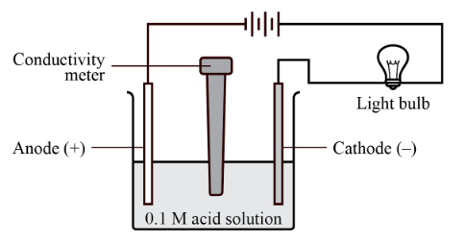

The brightness of the bulb for each acid are recorded in the table below.

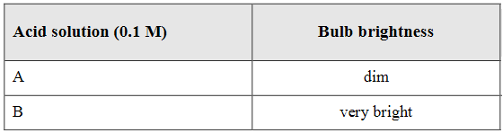

Which of the following gives the most likely identify of acids A and B?

* 1. Acid A sulfuric acid; Acid B nitric acid.
  2. Acid A ethanoic acid; Acid B hydrochloric acid.
  3. Acid A citric acid; Acid B ethanoic acid.
  4. Acid A nitric acid; Acid B phosphoric acid.

1. Identify the Brønsted-Lowry acids in this equation.



* 1. CH3CH2NH2 and H2O
  2. CH3CH2NH2 and OH-
  3. C2H5NH3+ and OH-
  4. H2O and C2H5NH3+

1. Equimolar solutions of NaCl(aq), NH4Cl(aq) and NaCH3COO(aq) were prepared.

In which of the following are these salt solutions listed from least to most acidic?

* 1. NaCl(aq), NH4Cl(aq), NaCH3COO(aq)
  2. NaCl(aq), NaCH3COO(aq), NH4Cl(aq)
  3. NH4Cl(aq), NaCl(aq), NaCH3COO(aq)
  4. NaCH3COO(aq), NaCl(aq), NH4Cl(aq)

**Part 2: Short Answer Section 31 Marks**

1. The electrolysis of carbon dioxide gas, CO2, in water is one way of making ethanol, C2H5OH. The diagram below shows a CO2–H2O electrolysis cell. The electrolyte used in the electrolysis cell is sodium hydrogen carbonate solution, NaHCO3(aq).

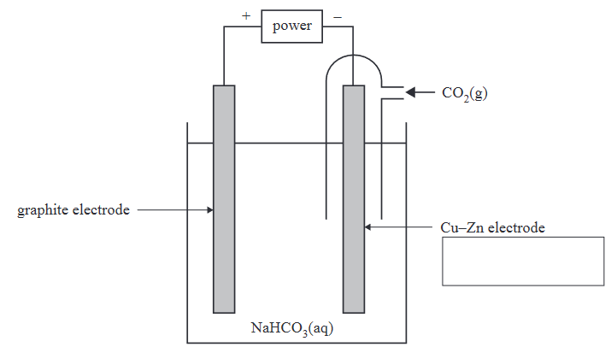

The following half-cell reactions occur in the CO2–H2O electrolysis cell.



* 1. Identify the Cu–Zn electrode as either the anode or the cathode in the box provided in the diagram above.

(1 mark)

* 1. Determine the applied voltage required for the electrolysis cell to operate.

(1 mark)

* 1. Write the balanced equation for the overall electrolysis reaction.

(1 mark)

* 1. Identify the oxidising agent in the electrolysis reaction. Give your reasoning using oxidation numbers.

(1 mark)

* 1. Explain with specific reference to standard reduction potentials why NaHCO3 is a suitable choice of electrolyte but AgHCO3 is not.

(4 marks)

* 1. Could the graphite electrode have been replaced with a copper electrode? Justify your response.

(2 marks)

* 1. Write observation/s for the events occurring at the graphite electrode.

(1 mark)

* 1. Will the electrolyte change in colour during electrolysis? If yes, what colour change will occur?

(1 mark)

* 1. Which ions will migrate during electrolysis and in which direction?

(2 marks)

* 1. Assuming other reactant/s are present in excess, what volume of CO2 at 100.0 kPa and 25 oC must be supplied to produce 10.0 g of ethanol? Assume that the cell operates at an efficiency of 58%.

(3 marks)

1. Most metals react with acids to produce hydrogen gas. On the other hand, copper does not usually react with acids. An exception to this is that copper will react with concentrated nitric acid. In this reaction however the oxidising agent is the nitrate ions, rather than the hydrogen ions. Also, the products of this reaction include nitrogen dioxide gas rather than hydrogen gas.

Using the method for balancing half-reactions in acidic solution, write half-reactions and an overall ionic reaction for the oxidation of copper with nitrate ions.

Reduction half-reaction

(1 mark)

Oxidation half-reaction

(1 mark)

Overall ionic reaction

(1 mark)

1. A buffer was prepared with ethanoic acid (CH3COOH) and sodium ethanoate. A few drops of universal indicator were then added. When small amounts of either 0.1 mol L–1 HCl(aq) or 0.1 mol L–1 NaOH(aq) were added, no change in the colour of the solution was observed. Explain these observations. Support your answer with at least ONE chemical equation.

(4 marks)

1. A student adds 1.17 g of Al(OH)3(s) to 0.500 L of 0.100 mol L–1 HCl(aq). Calculate the pH of the resulting solution. Also identify the limiting reagent. Assume that the volume of the resulting solution is 0.500 L.

(4 marks)

1. A standard solution of sodium carbonate is prepared by adding an accurately weighed amount of anhydrous sodium carbonate to a 250.0 mL volumetric flask and making the solution up to the calibration mark with distilled water. Measured aliquots of this standard solution are then titrated with a hydrochloric acid solution of unknown concentration. What will be the effect on the calculated concentration of hydrochloric acid (compared to its actual concentration) of each of the following? (Assume the only factor being altered is the one specifically identified and all other parts of the experiment are performed correctly.)

(3 marks; 1 mark off per wrong answer)

* 1. The solution in the volumetric flask has water added to a point just above the calibration mark.

* 1. The pipette is rinsed with water prior to measuring out an aliquot.

* 1. The chemist performing the titration is colour-blind and consistently adds more acid from the burette than needed.

* 1. The insides of the conical flask are washed down with de-ionised water during the titration.

* 1. The burette was rinsed with de-ionised water prior to being filled with the acid used for the titration.

END OF TEST